You can also insert larger bullets, if desired, as pictured below.

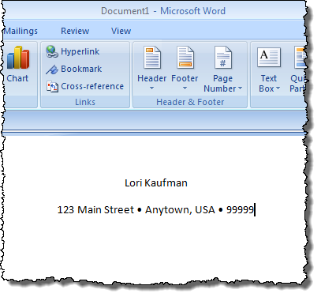

To insert a bullet graphically in Word 2007 or Word 2010, put the insertion point where you want to insert the bullet and click the **Insert** tab on the ribbon.

[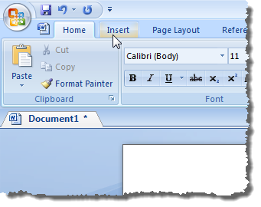](http://helpdeskgeek.com/wp-content/pictures/2011/01/03_clicking_insert_tab.png?d50c1d)

Click the **Symbol** button in the **Symbols** group. A palette of various symbols displays. If the bullet you want to insert displays in the palette, click the bullet character to insert it. If the bullet symbol you want to insert is not available on the palette, click **More Symbols**.

[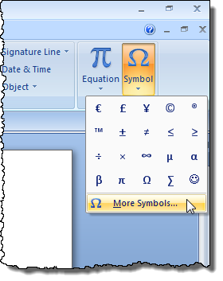](http://helpdeskgeek.com/wp-content/pictures/2011/01/04_clicking_more_symbols.png?d50c1d)

The **Shortcut key** for the selected bullet is listed at the bottom of the **Symbol** dialog box (**Alt + 0149** for the bullet we selected).

# spread out the items in a list

You can increase the space between the lines in all of your lists by clearing a check box.

1. On the **Home** tab, in the **Styles** group, click the **More** arrow next to the Styles gallery, and then right-click the List Paragra style.

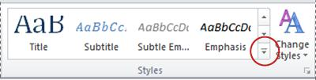

1. Click **Modify**.
2. In the **Modify Style** dialog box, click **Format**, and then click **Paragraph**.
3. Clear the **Don't add space between paragraphs of the same style** check box.

Move an entire list to the left or the right

1. Click a bullet or number in the list to highlight the list.
2. Drag the list to a new location.

The entire list moves as you drag. The numbering levels do not change.

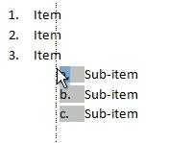

Turn a one-level list into a multilevel list

You can turn an existing list into a multilevel list by changing the hierarchical level of items in the list.

1. Click any item that you want to move to a different level.
2. On the **Home** tab, in the **Paragraph** group, click the arrow next to **Bullets** or **Numbering**, click **Change List Level**, and then click the level that you want.

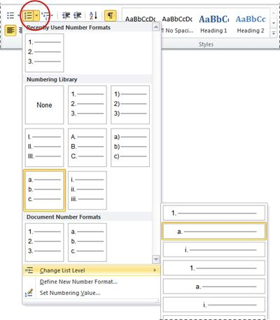

Choose a multilevel list style from the gallery

You can apply a gallery style to any multilevel list.

1. Click an item in the list.
2. On the **Home** tab, in the **Paragraph** group, click the arrow next to **Multilevel List**.

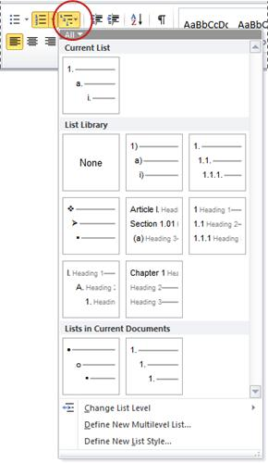

1. Click the multilevel list style that you want.

**Taken from: http://helpdeskgeek.com/office**